**TEST COMPLETION REPORT**



**PERFORMANCE TEST SUMMARY REPORT**

**Scientific Games International**

Version 1.0

March 21, 2025

**Documentation Policy**

**Document Name:** SG_PERFORMANCE_TEST_SUMMARY_REPORT-V1.0

**Date**: March 21, 2025

This document contains information confidential and proprietary to Scientific Games International, Inc. (SGI), a wholly owned subsidiary of Scientific Games Corporation (SGC) and may be protected by other forms of intellectual property. The information contained herein may not be reproduced, paraphrased, translated into another language, or otherwise disclosed or duplicated by any means without the prior written consent of SGI. Violators may be prosecuted. Due to the confidentiality of the subject matter, revisions or alterations are undertaken only by written agreement with SGI. Distribution of this document or any portion thereof may only be conducted by SGI or through its designated officials.

The software / systems described in this document are protected by copyright law. ***Unauthorized duplication or use of any software described herein is prohibited.*** Software features may be described herein which are not implemented in every system. Similarly, ongoing enhancements to this system may result in the presence of features on a particular system, which are not included in this edition of the document. Authorized users will be notified of software / systems modifications through the release of new editions of this documentation.

SGI MAKES NO WARRANTY, EXPRESSED OR IMPLIED, WITH REGARD TO THIS MATERIAL, INCLUDING BUT NOT LIMITED TO WARRANTIES OF MERCHANTABILITY OF FITNESS FOR ANY PARTICULAR PURPOSE. SGI ACCEPTS NO LIABILITY FOR ERRORS CONTAINED IN THIS DOCUMENT OR FOR INCIDENTAL OR CONSEQUENTIAL DAMAGES ASSOCIATED WITH ITS PROVISION, CONTENTS, OR USE.

© 2023 by Scientific Games International, Inc.

All rights reserved.

**Revision Record**

| Version | Date | Description | Authored By |
| --- | --- | --- | --- |
| 0.1 | 21-03-2025 | Initial draft | Rajesh Chaudhari |
| 1.0 | 21-03-2025 | Final Revised | Rajesh Chaudhari |
|  |  |  |  |

**Document Endorse & Approval**

| Name | Position | Organization | Approval Date |
| --- | --- | --- | --- |
| BROWN Robin | Senior Solution Architect, PM | Scientific Games | 21/03/2025 |

**Distribution List**

| Name | Position | Organization |
| --- | --- | --- |
| Tanya Syme | Principal Quality Assurance Manager | Lotto NZ |
| Gideon Lee | Quality Assurance Manager | Lotto NZ |
| Rachel Hughes | Test Manager | Assurity |
| Nishad Bhat | Performance Consultant | Assurity |
| LINDMAIER Stefan | Director, Customer Program Management | Scientific Games |
| PEARCE Nathaniel | Solution Delivery Manager | Scientific Games |
| MACGREGOR Stephen | Infrastructural Delivery Manager | Scientific Games |
| BROWN Robin | Senior Solution Architect, PM | Scientific Games |
| SYDLER Christian | Director, Network Engineering Infrastructure | Scientific Games |
| YARAMASA Murali | Test Manager | Planit |

**Contents**

SECTION 1 Summary 5

1.1 Purpose 5

1.2 Performance Testing Overview 5

SECTION 2 Test Coverage 6

2.1 In Scope 6

2.2 Out of Scope 6

SECTION 3 Performance Test Approach 7

SECTION 4 Non-Functional Requirements 8

SECTION 5 Test Results Summary 9

5.1 Performance Test Results Summary 9

5.1.1 Pre-Draw 9

5.1.2 Post-Draw 14

5.2 Outstanding Showstoppers and High priority Defects 15

SECTION 6 Appendix 16

# Summary

## Purpose

The purpose of this Test Summary Report is to document the results and outcomes of the SG Performance testing. It provides a detailed summary of the testing process, including an overview of test execution, test coverage, identified defects, and an overall quality assessment. The report offers stakeholders clear insights into whether performance testing objectives were achieved, outlines any unresolved issues or defects, and supports informed decision-making regarding the release candidate for T2 HAL or further steps needed to proceed with the release.

## Performance Testing Overview

As set out in [SG-Performance-Test-Plan-v0.3.docx](https://nzlotteries.sharepoint.com/:w:/r/sites/LottoNZScientificGames-ContractDocuments/Shared%20Documents/General/Testing/Non_Functional_Testing/Performance_Testing/SG-Performance-Test-Plan-v0.3.docx?d=w996e220bd1bf4a4a9a287107c16ef611&csf=1&web=1&e=nOC8aR), the planned scope of testing includes:

* The scope of the Phase 1 Performance Testing is focused on SGI components and the performance of integrated SGI components, specifically the API traffic between internal SG components under load. The primary objective is to ensure the robustness and performance of these components.
* User actions for the user journeys are simulated using SG APIs, which are mapped to LNZ-Mule APIs. The Apache JMeter tool is being used for simulation and to generate virtual load.
* Data from 43M draw is considered as baseline as this draw had higher player traffic compared to 50M draw.

Below diagram shows components involved in overall solution (LNZ + SG) and tested during Phase 1 and Phase 2.

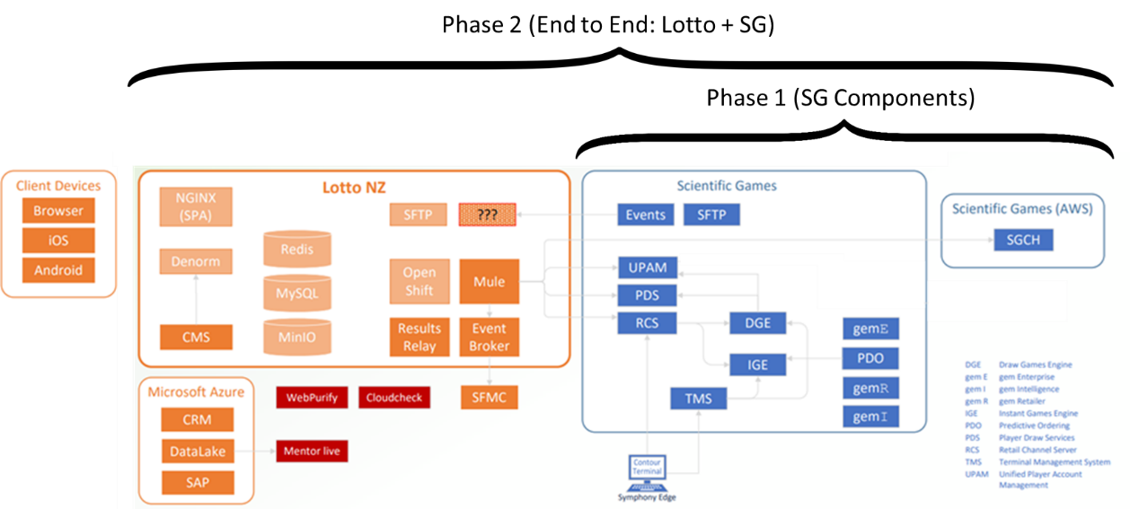

# Test Coverage

## In Scope

* **SG internal systems**
  + UPAM
  + SYMPHONY (DGE, PDS)
* **Dashboards**
  + Intuitive Grafana dashboards to monitor performance metrics during test executions. These dashboards will capture and display SG API Performance metrics only (response times & throughput).
  + There is a separate framework deployed for Production monitoring using Grafana & Kibana stacks.

## Out of Scope

* **Systems**
  + Lotto system (middleware Mule),
  + Any Other Applications (Windcave)
  + User journeys via Middleware Mule.
  + All other third-party peripherals from LNZ.
* **Non-Functional Testing**
  + Operability, Security, Maintainability, Portability, Usability.
  + High Availability / Failover Testing

# Performance Test Approach

|  |  |  |  |
| --- | --- | --- | --- |
| **#** | **Type** | **Objective** | **Steps** |
| **Test 1** | **Initial Throughput Validation for Register Wager API** | In accordance with the Non-Functional Requirements (NFRs) outlined in Section 4, simulate a workload that achieves a throughput of **3,000 wagers per minute** for the **Register Wager API**. This will establish the baseline for validating the system's performance. | 1. **Simulate the workload** to achieve the specified throughput of 3,000 wagers per minute for the Register Wager API. 2. **Monitor system performance** throughout the test to ensure the throughput target is met, while maintaining acceptable levels of response time and error rates. 3. **Evaluate the system’s configuration** to determine whether it can sustain the desired throughput without experiencing performance degradation. |
| **Test 2** | **Pre-Draw Scenario – System Scalability Test** | Simulate a **Pre-Draw** scenario workload and conduct iterative tests, progressively increasing throughput with each test. The aim is to identify the system's breakpoint for each SGI API, as specified in the throughput table. This will provide insights into the system's scalability, specifically in relation to the throughput capacity of individual APIs. | 1. **Execute Test 1** by increasing the target throughput by 50%, setting a new goal of 4,500 wagers per minute. 2. **Monitor system performance** throughout the test, focusing on key metrics such as response times, error rates, and consistency of throughput. 3. **Verify API performance** to ensure each API meets the throughput targets without experiencing failures or performance bottlenecks. 4. **Incrementally increase the throughput target** until a noticeable degradation in system performance is observed. |
| **Test 3** | **Post-Draw Scenario - Maximum Throughput** | Simulate a **Post-Draw** scenario workload and conduct iterative tests, progressively increasing throughput with each test. The aim is to identify the system's breakpoint for each SGI API, as specified in the throughput table. This will provide insights into the system's scalability, specifically in relation to the throughput capacity of individual APIs. | 1. **Execute Test** with Post-Draw workload **targeting throughput mentioned in** Post-Draw Throughput table) by increasing the target throughput by 50% 2. **Monitor system performance** throughout the test, focusing on key metrics such as response times, error rates, and consistency of throughput. 3. **Verify API performance** to ensure each API meets the throughput targets without experiencing failures or performance bottlenecks. 4. **Incrementally increase the throughput target** until a noticeable degradation in system performance is observed. |

# Non-Functional Requirements

Below NFR requirements are extracted from “**Lotto GSA Schedule 03 _ Lotto NZ Requirements / 3.0 Non-Functional Requirements**” document. These NFRs are related to Performance Testing only and mainly covered from performance test perspective.

|  |  |  |  |  |  |
| --- | --- | --- | --- | --- | --- |
| Req # | Mandatory / Specified | Area | Sub-Area | Requirement | Status |
| NFR 3.68 | Mandatory | Gaming Quantitative Performance Criteria | Capacity | The system must support current sales, and peak sales periods.  **Current Average sales:** GAME, Tickets, Lines in a day Lotto 1,659,245 14,441,306 Powerball 1,594,794 13,972,522 (subset of lotto) Strike 888,841 1,741,245 Keno 35,639 121,429 Bullseye 160,448 174,240 | Achieved Currently 82M wagers |
| NFR 3.69 | Mandatory | Gaming Quantitative Performance Criteria | Capacity | The system must allow for sales growth and be scalable to accommodate future growth and peaks as per the main RFP document growth projections | Achieved Supporting 6000 Wagers per minute |
| NFR 3.71 | Mandatory | Gaming Quantitative Performance Criteria | Capacity | The system must support at a minimum registration of technically up to 1.8 million named players with capacity to support additional registrations | Achieved Currently 2.7 M Players |
| NFR 3.72 | Mandatory | Gaming Quantitative Performance Criteria | Throughput Performance | The system must have capacity for **3,000 Wagers Per Minute** in the digital channel. The system must have capacity for this peak as well as expected growth of the digital channel. | Achieved Supporting 6000 Wagers per minute |
| NFR 3.73 | Mandatory | Gaming Quantitative Performance Criteria | Throughput Performance | The system must ensure that each single play (single panel) printed ticket at the Retailer must be produced in no more than two (2) seconds from completion of data entry ("Send" is pressed) | Achieved  Manually Verified on Terminals |
| NFR 3.76 | Mandatory | Gaming Quantitative Performance Criteria | Throughput Performance | The system must ensure that all other transactions within the supplier’s System (e.g., winning ticket validations, cancels and brief DBG and Instant Kiwi card ticket reports, etc.) are processed in less than two (2) seconds within the System i.e. it must take less than two (2) seconds from point of entry to point of exit from the System for the relevant transaction. For further clarity, examples of points of entry include: a request from the Front-end; a request by an administrative user in the backend of the System; or request from a retail terminal. | Achieved  Manually Verified on Terminals. IKO related tests are in progress |
| NFR 3.31 | Mandatory | Performance | Response Times | The system must have the following minimum response time for sign in: Time between valid sign in request and presentation of landing page < 2 sec for sign in requests, The system must have the following minimum response time for user action: Time between valid action and presentation of result < 2 sec for user actions. | Achieved  Based on Performance Test Results |
| NFR 3.32 | Mandatory | Performance | Response Times | The system must ensure that information is displayed on the LottoNZ Admin workstation within 2 seconds of it being requested by the LottoNZ user | Achieved  Verified on Terminals |
| NFR 3.33 | Mandatory | Performance | Response Times | The Retailer Terminals will take no longer than 2 seconds to respond to a command | Achieved  Verified on Terminals |
| NFR 3.34 | Mandatory | Performance | Volumes | The system must have the capacity to support a minimum of 3000 wagers per minute and allow for growth of the throughout as per the projections in the main RFP document | Achieved Supporting 6000 Wagers per minute |

# Test Results Summary

## Performance Test Results Summary

The performance tests indicated that the NFR of 3000 wagers per minute was achieved and achieved future growth up to **6000 wagers per minute**, with an average response time of less than **650ms**.

All front end user actions for user journeys were simulated using SG APIs (mapped to LNZ-Mule APIs)

**Mule to SGI API Mapping:**



## Pre-Draw

|  |  |
| --- | --- |
| **Date** | 05/03/2025 |
| **Time** | 10:10 – 10:26 |
| **Scenario** | Pre-Draw |
| **APIs targeted** | POST - /pfi/login?type=player (SG UPAM)  GET - /pfi/wallets/{playerId} (SG UPAM)  GET - /pfi/players/{playerId}/winnings-to-process (SG UPAM)  GET - /pfi/profile/players/{playerId}/details (SG UPAM)  GET - /pfi/players/{playerId}/payment-methods (SG UPAM)  GET - /pfi/exclusions/players/{playerId} (SG UPAM)  GET - /pfi/limits/players/{playerId} (SG UPAM)  GET - /pfi/players/{playerId}/game-history (SG UPAM)  POST - /wager-history-api/v1/wagers/get-many (SG PDS)  GET - /draw-history-api/v1/games/{gameId}/draws/{drawNo} (SG PDS)  POST - /rcs-dge-wager/v1/wagers (SG DGE) |
| **Throughput Achieved** | **60 TPS (3600 TPM)** |
| **Status** | Pass |
| **Error %** | 0.13% [Internal Server Error (HTTP 504)] |

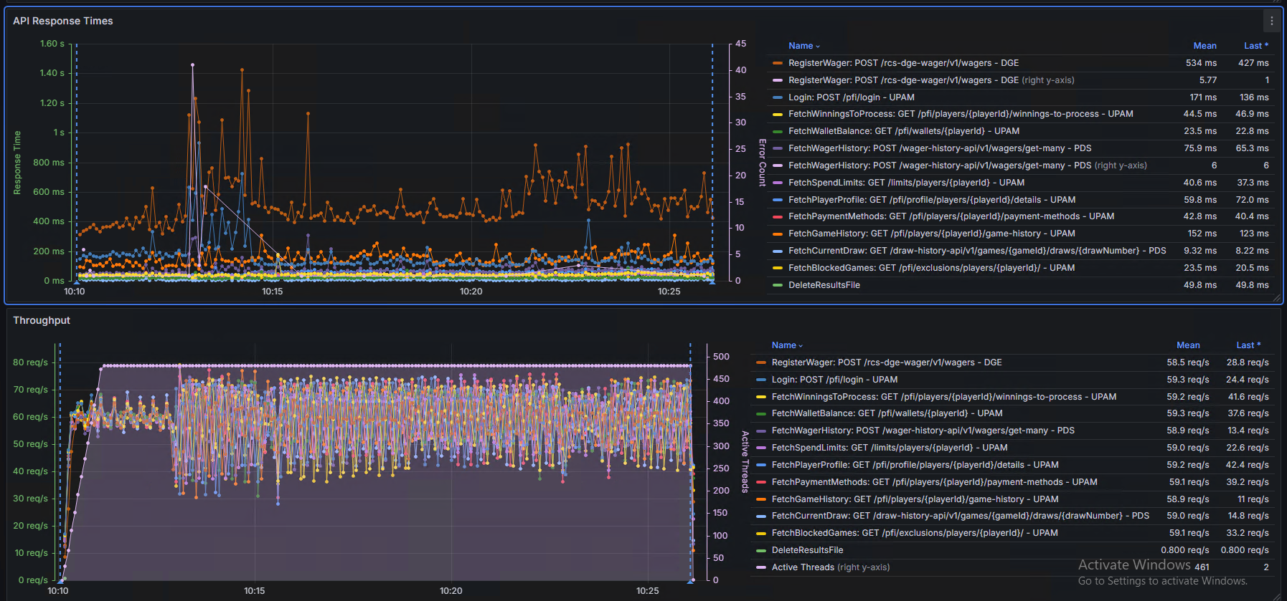

|  |  |
| --- | --- |
| **Date** | 10/03/2025 |
| **Time** | 20:09 – 20:27 |
| **Scenario** | Register Wager Only |
| **APIs targeted** | POST - /rcs-dge-wager/v1/wagers (SG DGE) |
| **Throughput Achieved** | **60 TPS (3600 TPM)** |
| **Status** | Pass |
| **Error %** | 0% |

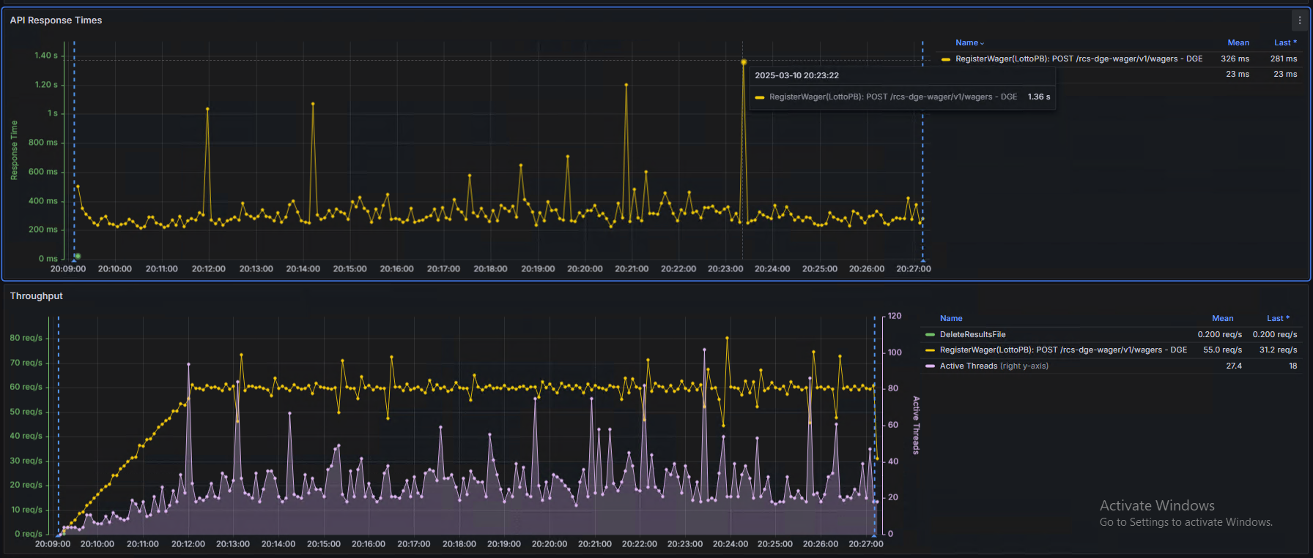

|  |  |
| --- | --- |
| **Date** | 10/03/2025 |
| **Time** | 21:07 – 21:25 |
| **Scenario** | Register Wager Only |
| **APIs targeted** | POST - /rcs-dge-wager/v1/wagers (SG DGE) |
| **Throughput Achieved** | **80 TPS (4800 TPM)** |
| **Status** | Pass |
| **Error %** | 0.07% [Internal Server Error (HTTP 504)] |

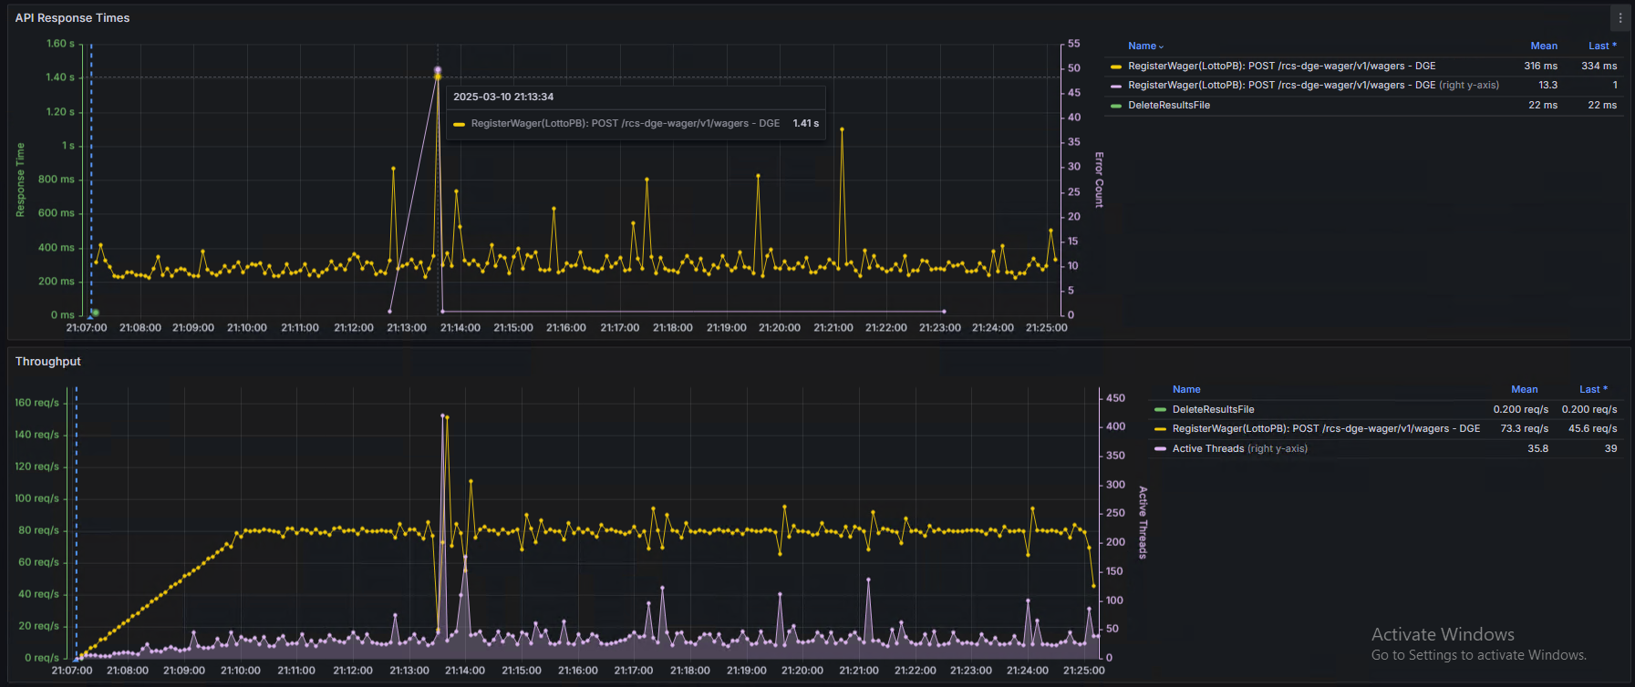

|  |  |
| --- | --- |
| **Date** | 10/03/2025 |
| **Time** | 22:42 – 23:00 |
| **Scenario** | Register Wager Only |
| **APIs targeted** | POST - /rcs-dge-wager/v1/wagers (SG DGE) |
| **Throughput Achieved** | **100 TPS (6000 TPM)** |
| **Status** | Pass |
| **Error %** | 0.99% [Internal Server Error (HTTP 504)] |

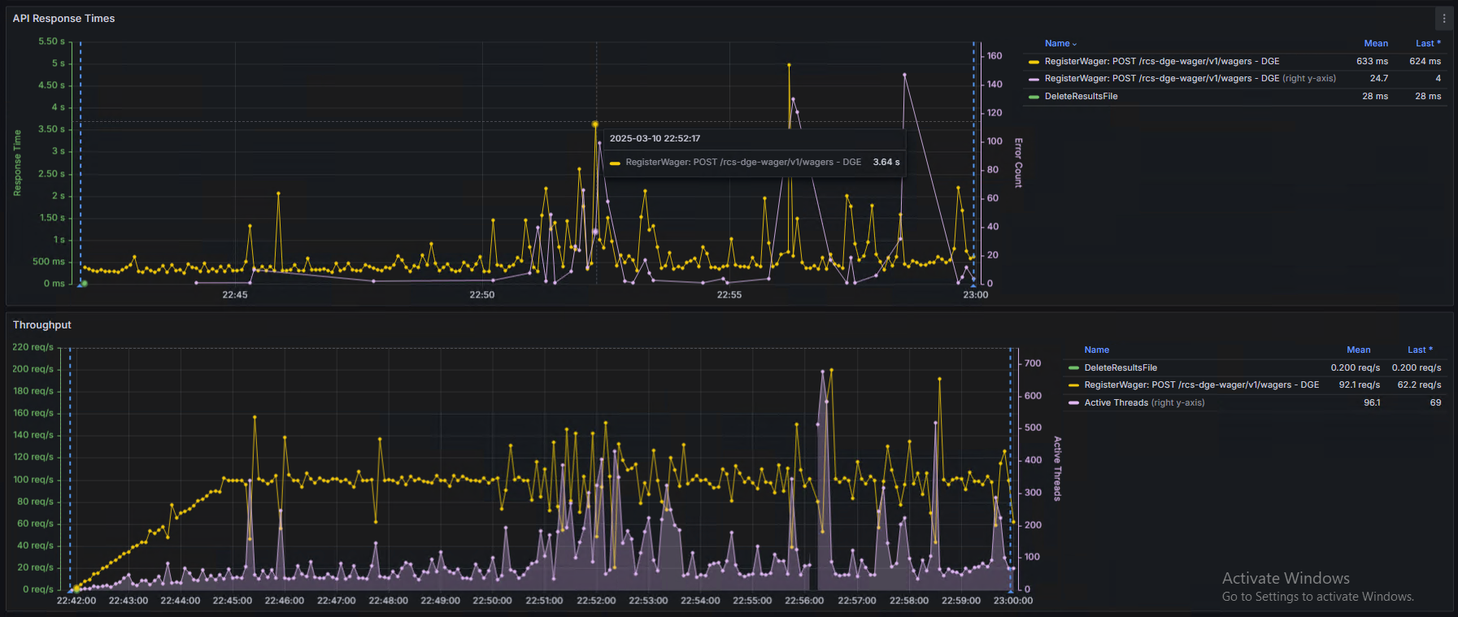

|  |  |
| --- | --- |
| **Date** | 11/03/2025 |
| **Time** | 12:55 – 13:13 |
| **Scenario** | Pre-Draw |
| **APIs targeted** | POST - /pfi/login?type=player (SG UPAM)  GET - /pfi/wallets/{playerId} (SG UPAM)  GET - /pfi/players/{playerId}/winnings-to-process (SG UPAM)  GET - /pfi/profile/players/{playerId}/details (SG UPAM)  GET - /pfi/players/{playerId}/payment-methods (SG UPAM)  GET - /pfi/exclusions/players/{playerId} (SG UPAM)  GET - /pfi/limits/players/{playerId} (SG UPAM)  GET - /pfi/players/{playerId}/game-history (SG UPAM)  POST - /wager-history-api/v1/wagers/get-many (SG PDS)  GET - /draw-history-api/v1/games/{gameId}/draws/{drawNo} (SG PDS)  **GET - /draw-history-api/v1/games/{gameId}draws/next?by=SELL_END_DATE (SG PDS)**  **GET - /pfi/profile/players/{playerId}/favorite-bets (SG UPAM)**  POST - /rcs-dge-wager/v1/wagers (SG DGE) |
| **Throughput Achieved** | 60 TPS (3600 TPM) |
| **Status** | Pass |
| **Error %** | 0.51% [Internal Server Error (HTTP 504)] |

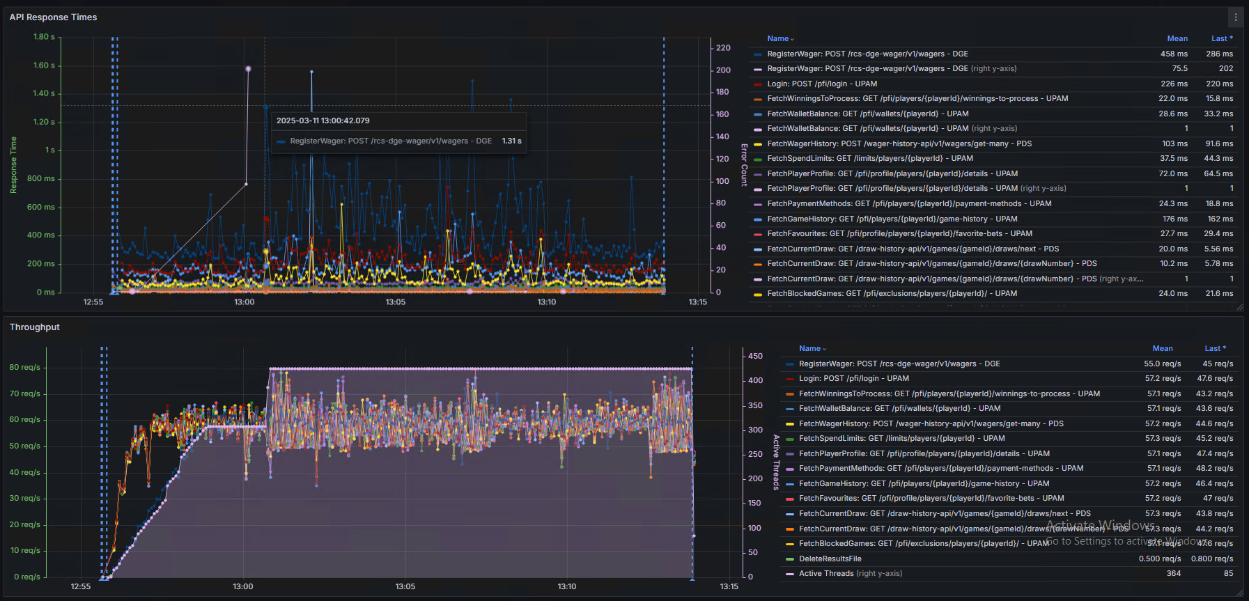

|  |  |
| --- | --- |
| **Date** | 21/03/2025 |
| **Time** | 11:23 – 11:56 |
| **Scenario** | Register Wager Only |
| **APIs targeted** | POST - /rcs-dge-wager/v1/wagers (SG DGE) |
| **Throughput Achieved** | **60 TPS (3600 TPM)** |
| **Status** | Pass |
| **Error %** | 0% |

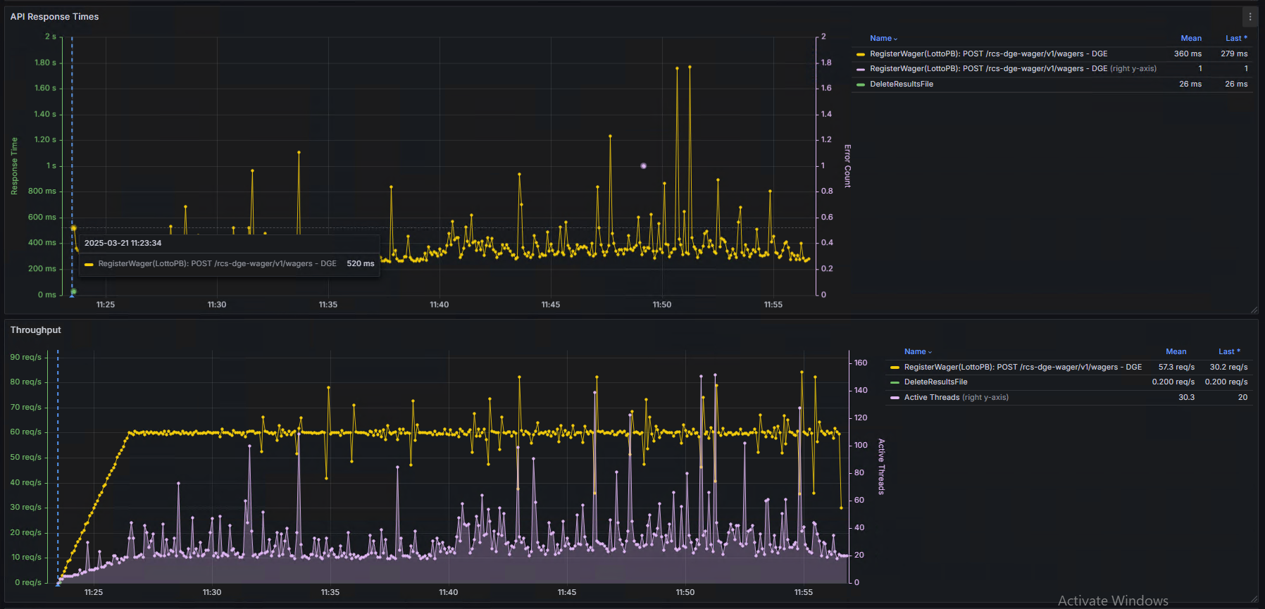

|  |  |
| --- | --- |
| **Date** | 21/03/2025 |
| **Time** | 15:10 – 15:45 |
| **Scenario** | Pre-Draw |
| **APIs targeted** | POST - /pfi/login?type=player (SG UPAM)  GET - /pfi/wallets/{playerId} (SG UPAM)  GET - /pfi/players/{playerId}/winnings-to-process (SG UPAM)  GET - /pfi/profile/players/{playerId}/details (SG UPAM)  GET - /pfi/players/{playerId}/payment-methods (SG UPAM)  GET - /pfi/exclusions/players/{playerId} (SG UPAM)  GET - /pfi/limits/players/{playerId} (SG UPAM)  GET - /pfi/players/{playerId}/game-history (SG UPAM)  POST - /wager-history-api/v1/wagers/get-many (SG PDS)  GET - /draw-history-api/v1/games/{gameId}/draws/{drawNo} (SG PDS)  GET - /draw-history-api/v1/games/{gameId}draws/next?by=SELL_END_DATE (SG PDS)  GET - /pfi/profile/players/{playerId}/favorite-bets (SG UPAM)  POST - /rcs-dge-wager/v1/wagers (SG DGE) |
| **Throughput Achieved** | 55 TPS (3300 TPM) |
| **Status** | Pass |
| **Error %** | 0.64% [Internal Server Error (HTTP 504)] |

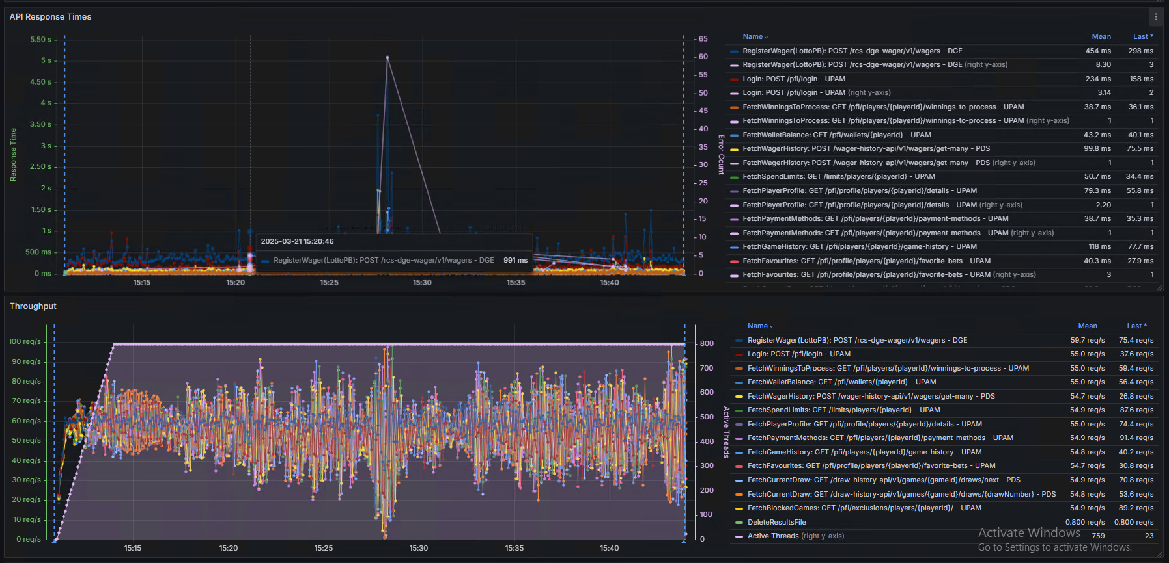

## Post-Draw

We will continue Post-Draw scenario once all draws are successfully completed. This test will be executed once all necessary Draw (Strike & PB) Processing is completed. Next step is to complDraw processing is in Progress and work with LNZ performance testing team in conjunction.

|  |  |
| --- | --- |
| **Date** |  |
| **Time** |  |
| **Scenario** | Post-Draw |
| **APIs targeted** | POST - /pfi/login?type=player (SG UPAM)  GET - /pfi/players/{playerId}/winnings-to-process (SG UPAM)  GET - /draw-history-api/v1/games/{gameId}/draws/{drawNo} (SG PDS)  GET - /draw-history-api/v1/games/{gameId}draws/next?by=SELL_END_DATE (SG PDS)  GET - /pfi/exclusions/players/{playerId} (SG UPAM)  GET - /pfi/limits/players/{playerId} (SG UPAM)  GET - /pfi/players/{playerId}/game-history (SG UPAM)  GET - /pfi/players/{playerId}/payment-methods (SG UPAM)  **GET - /pfi/players/{playerId}/winnings-to-process (SG UPAM)**  GET - /pfi/profile/players/{playerId}/details (SG UPAM)  GET - /pfi/profile/players/{playerId}/favorite-bets (SG UPAM)  GET - /pfi/wallets/{playerId} (SG UPAM)  **GET - /wager-history-api/v1/wagers?wagerIds={serialNumber} (SG PDS)**  **PATCH - /rcs-ige-prize-payout/v1/tickets/{ticketNo}/prize-inquiry (SG IGE)**  POST - /pfi/players/{playerId}/deposits (SG UPAM)  POST - /wager-history-api/v1/wagers/get-many (SG PDS) |
| **Throughput Targeted** | 60 TPS (3600 TPM) |
| **Status** |  |

## Outstanding Showstoppers and High priority Defects

The following table outlines the defects and issues that remain open at the completion of testing, along with a summary and Status.

|  |  |  |  |  |  |
| --- | --- | --- | --- | --- | --- |
| **JIRA #** | **Summary** | **App** | **Priority** | **Status** | **Due Date** |
| [SGLNZ-1464](https://jira.scigames.at/browse/SGLNZ-1464) | (T2 HAL Performance) Internal Server Error (HTTP 504) logged for Register Wager API under Load | UPAM | Medium | In Progress | 27-03-2025 |
| [SGLNZ-1909](https://jira.scigames.at/browse/SGLNZ-1909) | [T2 HAL] DGE Draw Processing does not work as expected (DGEBPUP batch crashing) | DGE | Medium | Resolved. Verification in progress | 27-03-2025 |

# Appendix

**Next Schedule**

* Support LNZ Performance Testing & Monitoring
* Continue Post–Draw Testing – 1 week to test
* Collaborate with LNZ on HA testing – 21st – 25th April